Model Development Phase

Date | 15 February 2026
Team ID | LTVIP2026TMIDS66979
Project Title | Explore With Ai: Custom Itineraries For Your Next Journey
Maximum Marks | 10 Marks

Initial Model Training Code, Model Validation and Evaluation Report
This project uses a pre-trained generative AI model and does not involve custom model training. Therefore, this phase focuses on model initialization, prompt-based interaction, and output evaluation instead of traditional training and validation.

Model Initialization and Integration (5 marks):
The generative AI model used in this project is a pre-trained Gemini Flash model provided through the Google Generative AI API. The model is initialized using a secure API key configuration and integrated into the application backend.
The model receives structured textual prompts containing user inputs such as destination, number of days, and number of nights. Based on this input, the model generates a detailed and personalized travel itinerary.
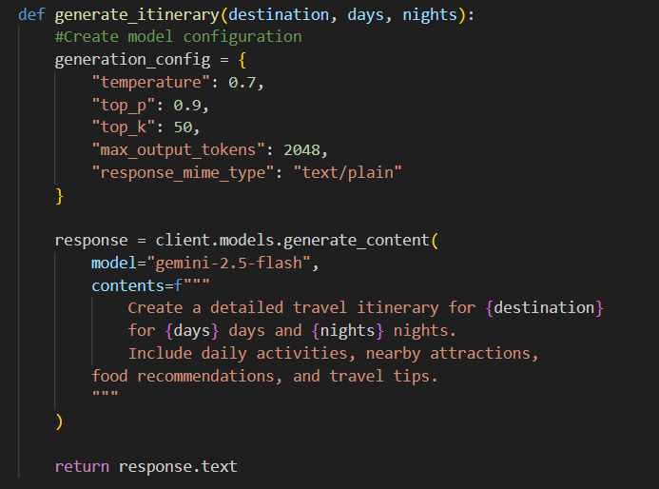

Model Validation and Evaluation Report (5 marks):
Since the model is pre-trained, validation is performed through functional testing and output quality assessment rather than numerical performance metrics.
Evaluation Criteria Used:
- Relevance of the generated itinerary to the selected destination
- Logical distribution of activities across days
- Completeness of itinerary (activities, attractions, food suggestions)
- Response consistency for different inputs
Multiple test inputs were provided to the system, and the generated outputs were reviewed to ensure accuracy, coherence, and usefulness.

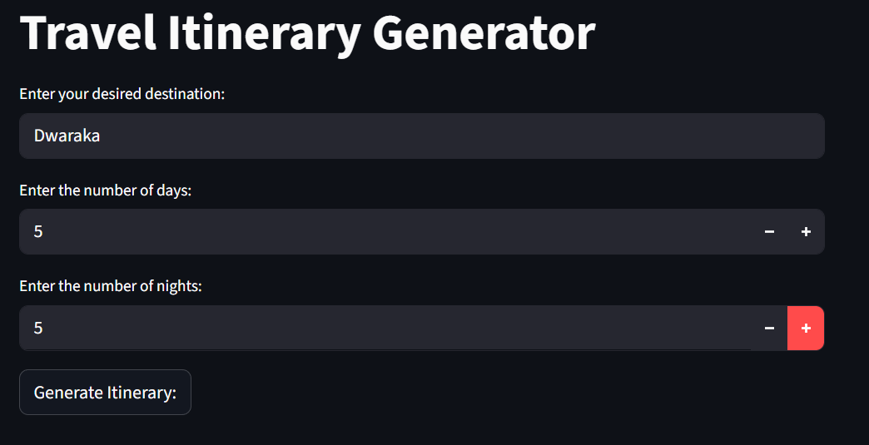
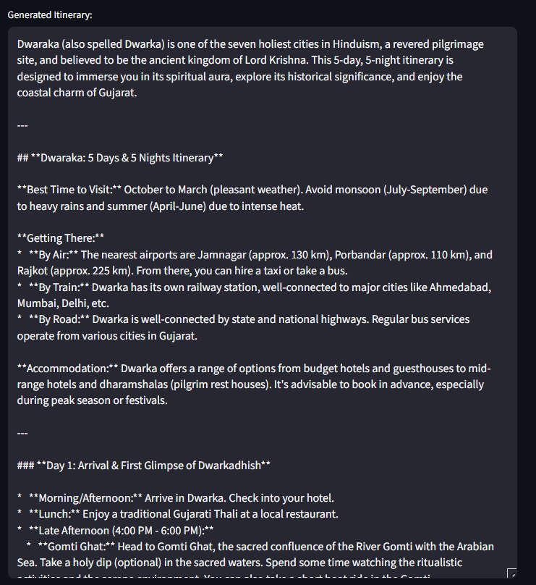

Model | Summary | Evaluation Method
Gemini Flash Lite | Large Language Model used via API | Output quality validation through multiple test cases

